|  |  |
| --- | --- |
| Assignment 3  ITRI 613 | Enrico Dreyer  31210783 |

Table of Contents

Part A 2

Question 1 2

Question 2 3

Question 3 4

Question 4 5

Question 5 6

Part B 7

Question 1 7

Question 2 8

Question 3 9

Question 4 10

Question 5 11

# Part A

## Question 1

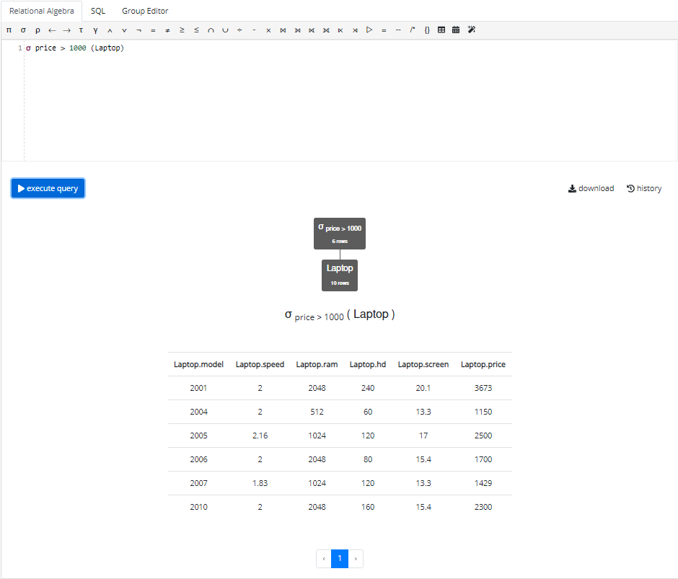

## Question 2

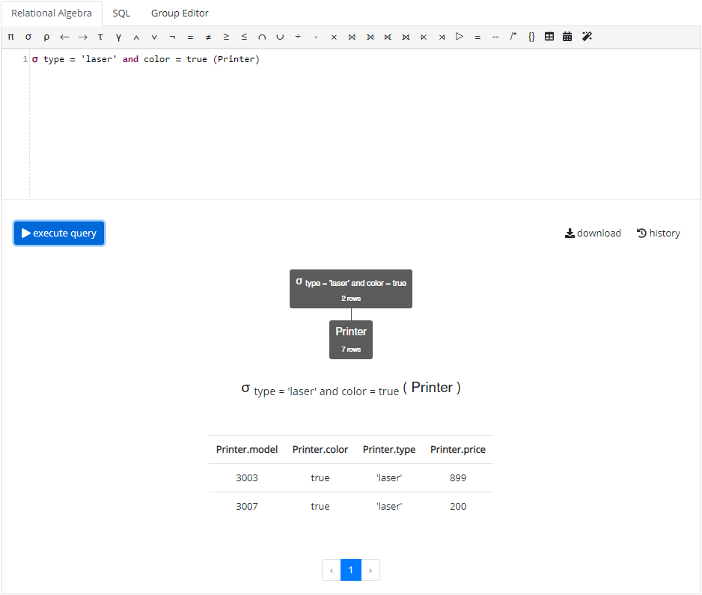

## Question 3

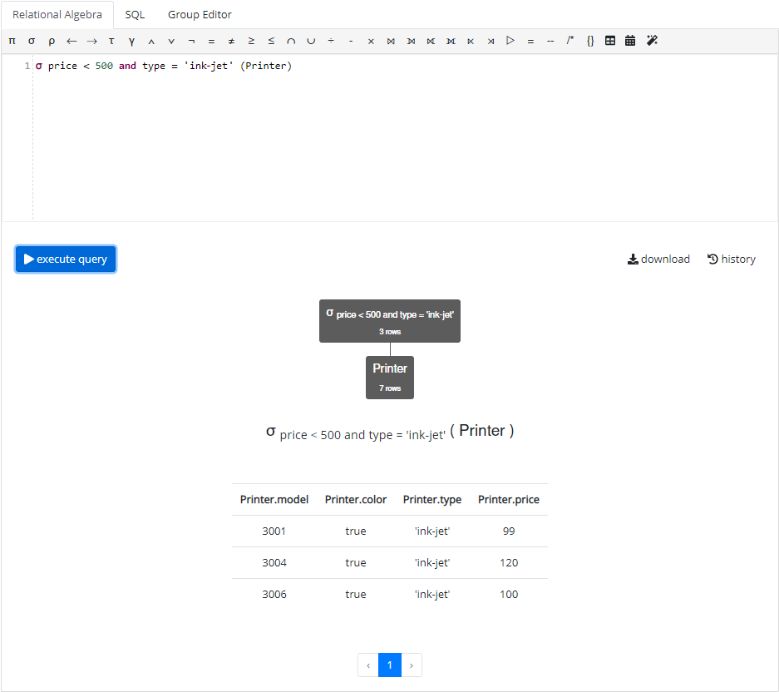

## Question 4

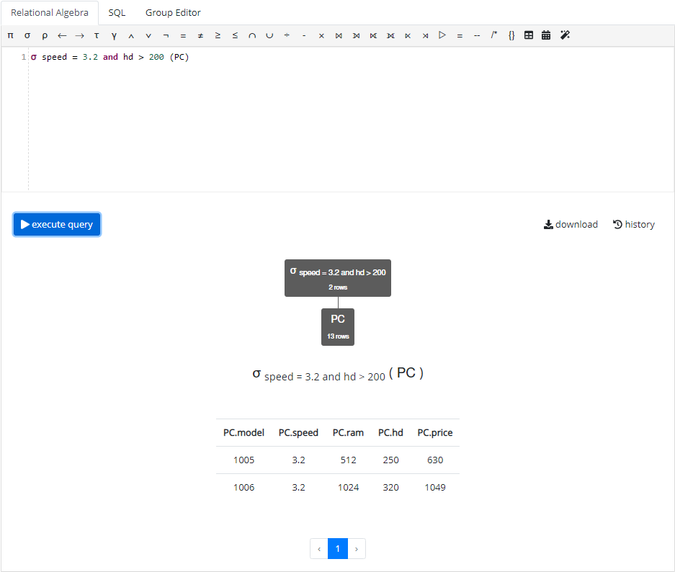

## Question 5

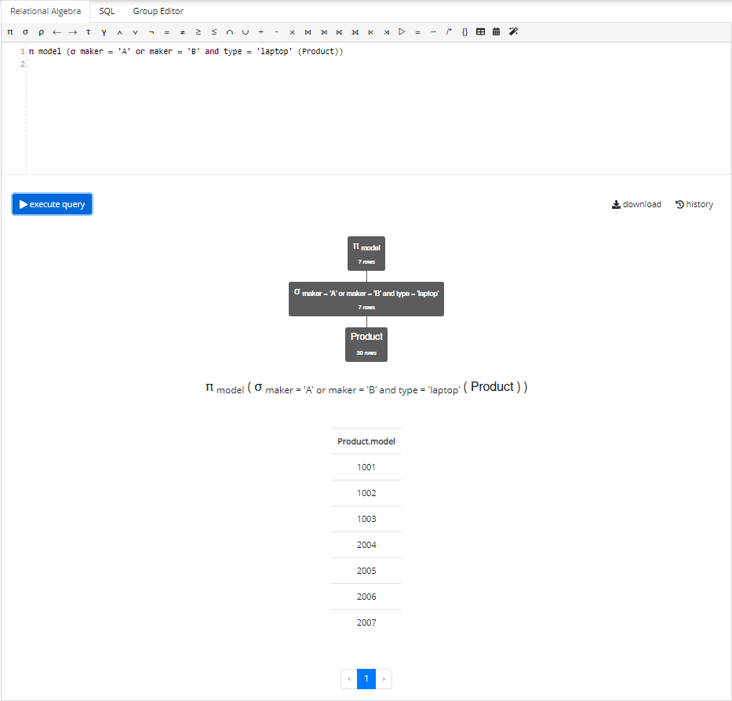

# Part B

## Question 1

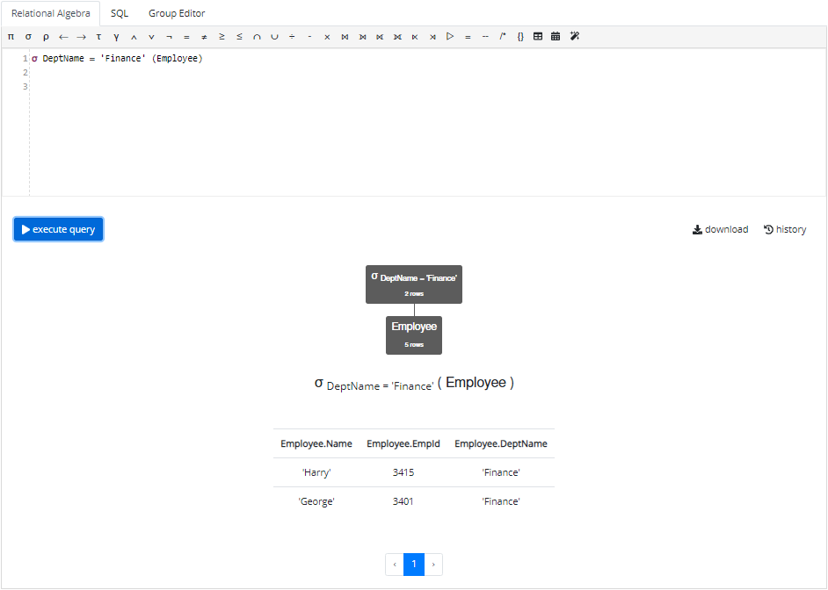

## Question 2

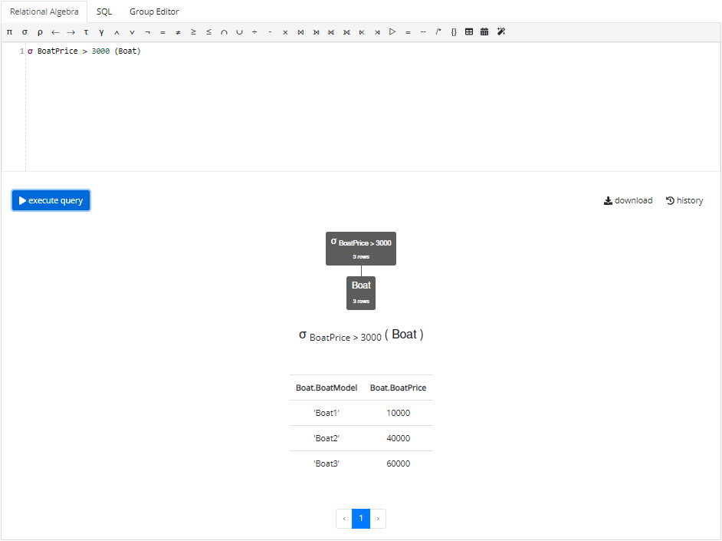

## Question 3

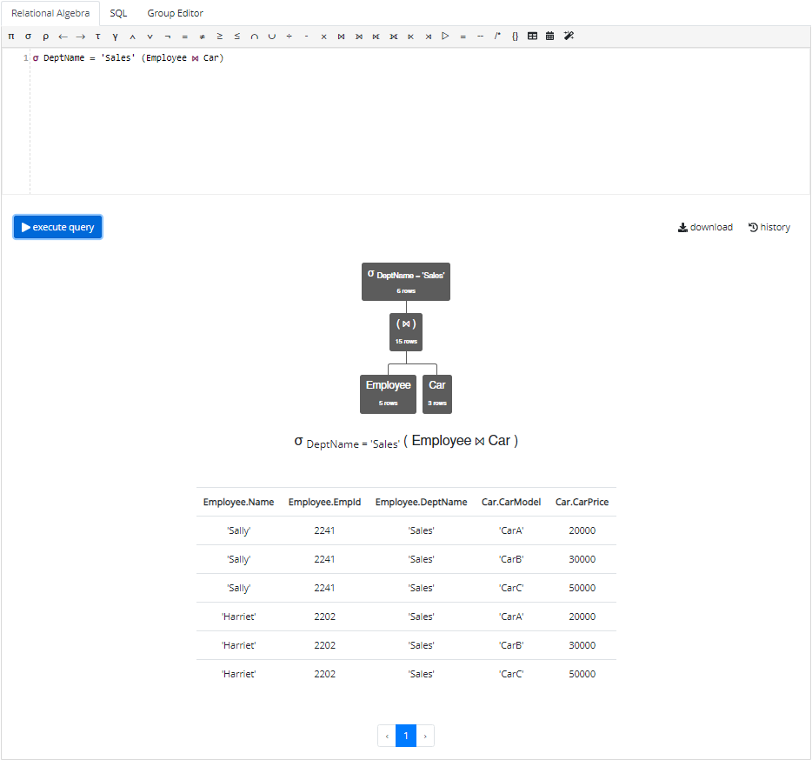

## Question 4

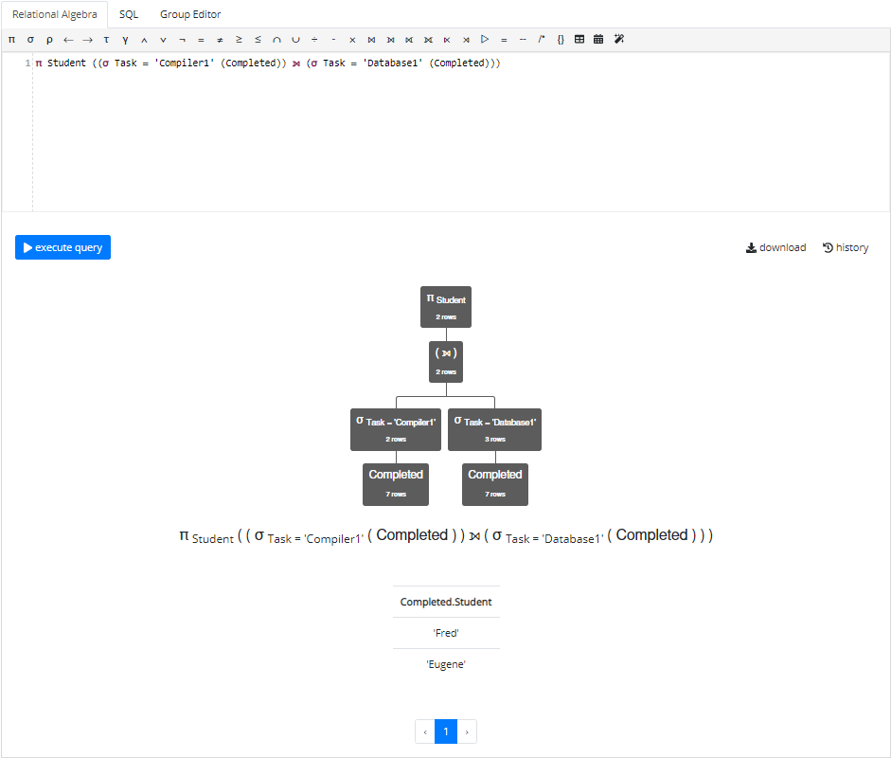

## Question 5

